Payroll Management System for Information Technology Company

Version 1.0

Revision History

|  |  |  |  |
| --- | --- | --- | --- |
| **Date** | **Version** | **Description** | **Author** |
| 16/12/2019 | 1.0 | Final | Quản Trọng Tú |
|  |  |  |  |
|  |  |  |  |
|  |  |  |  |

Table of Contents

1. Use-Case Name 4

1.1 Brief Description 4

2. Flow of Events 4

2.1 Basic Flow 4

3. Special Requirements 4

4. Preconditions 4

5. Postconditions 4

6. Extension Points 4

# Use-Case Name

## Brief Description

This use case defines the steps of assigning a project to user and store it in the database system. Administrator can easily assign a project for many users in a company.

# Flow of Events

## Basic Flow

The administrator accesses the management project view and click assign button to create assign form. Administrator enter fully information and click assign to update user’ salary in project.

­­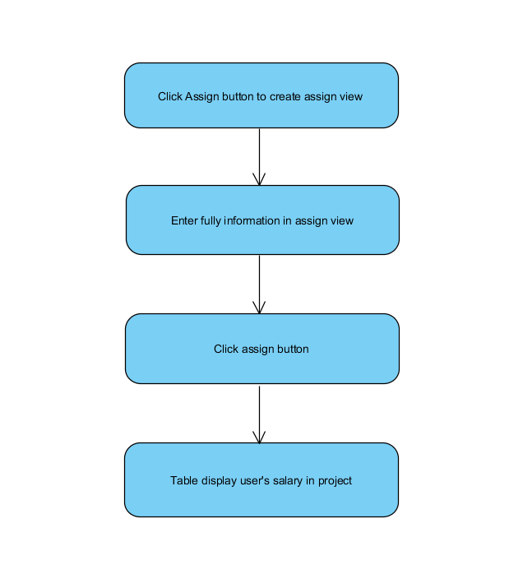

# Special Requirements

Projects have to initialize before.

# Preconditions

* Admin have to login into application and access manage project view

# Postconditions

* Application show a message to users if its success or failure.

# Extension Points

No extension points.